CASE-1:
A customer wants to withdraw money using an ATM. First, the customer inserts the card into the ATM. The ATM verifies the customer's authentication details. If authentication is successful, the ATM confirms verification and accepts a withdrawal request from the customer. If authentication fails, the ATM denies the request. After receiving the withdrawal request, the ATM checks its validity. If the request is valid, the withdrawal is completed; otherwise, the request is declined. Draw a UML Sequence Diagram for this scenario.

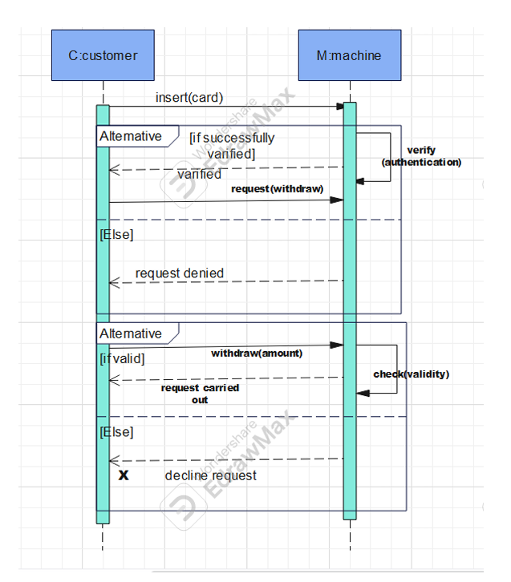

CASE-2:
A student wants to borrow books from a library. The student first sends a borrowing request to the librarian. The librarian scans the student's ID and forwards the request to the borrowing system. The borrowing system checks the student's status from the library database. If the student is regular and has no overdue books, the database allows the request, the borrowing system informs the librarian, and the librarian applies the borrowing request for the student. Otherwise, the database denies the request, the borrowing system notifies the librarian, and no book scanning or borrowing operation is performed. Draw a UML Sequence Diagram for this scenario.

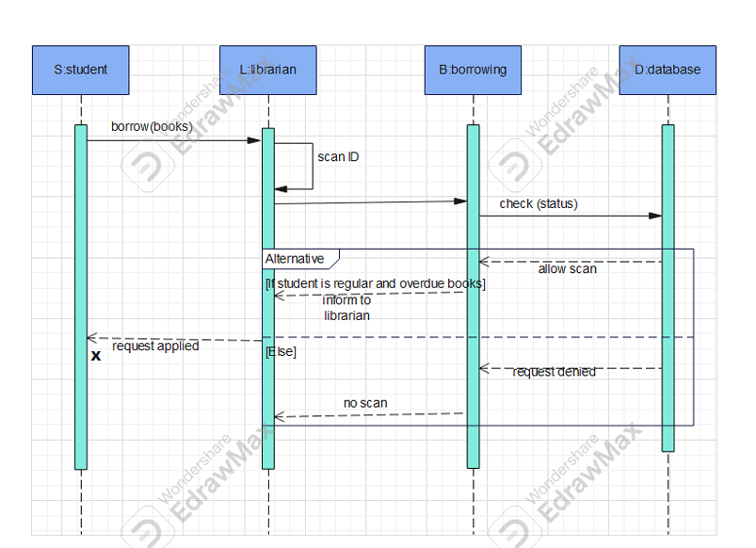

CASE-3:
A patient wants to book a hospital bed. The patient first sends a bed request to the system. The system checks the patient’s doctor/reference information from the database. If the reference is valid and an appropriate doctor is available, the request is accepted for further processing; otherwise, the request is denied. The system then checks the availability of the required facility or bed in the database. If it is available, the system sends the available information to the patient, the patient submits a booking request, and the system confirms and stores the booking in the database. If the facility is unavailable, the request is denied. Draw a UML Sequence Diagram for this scenario.

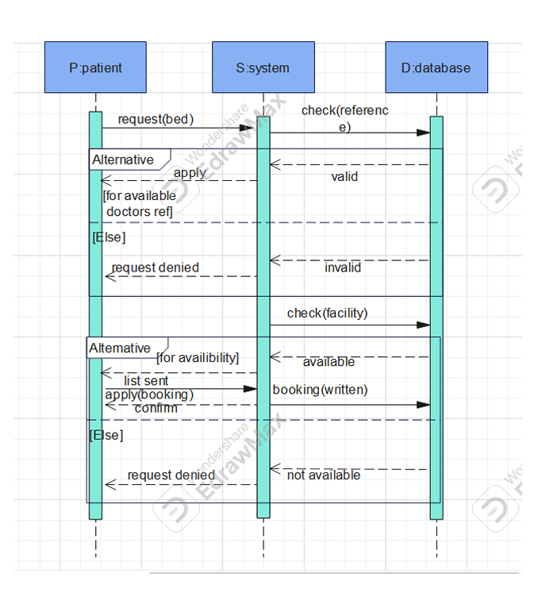

CASE-4:
A user wants to log in to a system. The user sends a login request to the session. The session sends the verification information to the database. The database verifies the supplied login information. If verification is unsuccessful, the verification process is repeated while the number of attempts is three or fewer. If the verification becomes successful within the allowed attempts, the database notifies the session that the login is successful. Otherwise, after the allowed attempts are exhausted, the database blocks the user and informs the session. Finally, the session notifies the user of the result. Draw a UML Sequence Diagram for this scenario.

